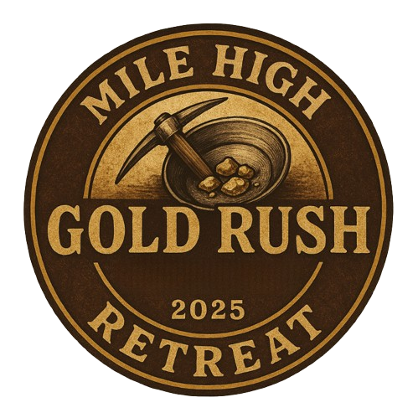
2025 MILE HIGH CHAPTER OF ALA
ANNUAL CONFERENCE

Thursday, October 9-Saturday, October 11, 2025

Strike Gold at the 2025 Mile High ALA Conference & Business Partner Expo!
Join us at the historic Mining Exchange Hotel in downtown Colorado Springs—once a bustling hub during the Pikes Peak Gold Rush—for a
two-night conference filled with discovery, connection, and pure Mile High treasure.

Hosted by the Professional Development and Business Partner Committees, this Gold Rush–themed adventure offers a rich mix of education and networking—all for $249!

Pan for professional gold with three dynamic sessions led by Gail and Bruce Montgomery, dig into the Business Partner Expo, and stake your claim at our Thursday welcome reception, hearty breakfasts, and Friday night cocktail hour and dinner.

Don’t miss your chance to mine knowledge, strike up connections, and leave with a nugget or two of inspiration!

Thanks to the golden support from our high-stakes prospectors, the Red Rocks Business Partners.








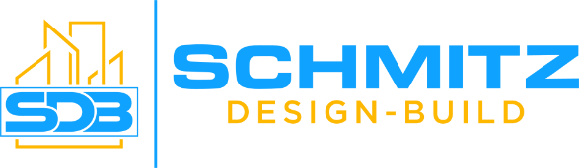

REGISTRATION DEADLINE: Wednesday, September 24, 2025
Visit www.milehighala.com to Register Today!


CONFERENCE SPEAKERS

Gail Montgomery, CEO & Co-Founder

Gail is on a mission to transform the training and development of teams and leaders. With so much data to support the ineffectiveness of current training, she was inspired to co-create a training approach that is consumable in smaller bites, over time. New behaviors and language can be practiced, refined and applied. She believes in the power of putting people first and has prioritized delivering hybrid training programs that are engaging, fun, and effective.
With a unique background in Human Resources, Change Management, and Training, Gail believes in “smashing” the box, loving the deep-end and ensuring fun comes first. She has worked in Corporate Human Resources as a recruiter for a Fortune 50 Global insurance company, as an Executive Director for a Non-profit Arts organization, and as a Director for a SAAS tech start-up developing Change Management and Training and Onboarding programs.
Her data-supported and proven approach helps businesses get to solutions faster, leaders and teams to work more efficiently and effectively together and positively strengthen culture. Unique and impactful, Gail’s human-centric strategies produce increased trust, belonging and productivity.
Gail is Mom to two adult children, wife to her partner in business and laughter Bruce, a certified Emotional Intelligence Practitioner, a member of the AMCP (Association of Change Management Professionals), and Co-Author of two books: “The Improv Mindset” and “CHANGE! A Leaders Guide to Fixing Sh*t.”
Affiliated with Vistage Worldwide, Gail and Bruce deliver engaging "duo-notes" on Improv Mindset and Emotional Intelligence (among others) to global CEOs and leaders.

Bruce Montgomery, President & Co-Founder

Bruce has broad business experience, ranging from leading the IT organization for one of the country’s largest non-profit theatres, to driving value through strong relationships as the leader of Key Accounts for a sports and entertainment analytics company (delighting top-tier clients such as: NHL, NFL, NASCAR, and The Shubert Organization).
Prior experience includes over 15 years in IT and Management consulting, where he focused on driving adoption through structured change management and training & development.
Bruce is passionate about business-driven creativity and innovation, focusing on improving adoption through experiential and immersive engagements. He places great importance on partnering with organizations to help develop healthy cultures that lead to measurable success.
Bruce is a graduate of the University of Denver EMBA program and has been a faculty partner ever since. He is also involved with world-renowned researchers such as Charles Limb to better understand the inner workings of the brain while performing creative acts, and Ellen Langer to determine the best methods for increasing productivity through creativity. Much of these approaches are documented in the books he co-wrote with Gail; “The Improv Mindset” and "CHANGE! A Leader’s Guide to Fixing Sh*t." He is also the author of the comic thriller "Terror in the Desert", for which he did the voice-over work, as well.

For those who need continuing education credits all three of Gail and Bruce’s sessions have been submitted for CLM, HRCI & SHRM re-certification credits.

CONFERENCE SESSIONS

SESSION 1:
Thriving In Uncertainty
Friday Morning

In this energizing kickoff session, participants will explore how to navigate uncertainty with clarity, confidence, and connection. Using tools from neuroscience and improvisation, attendees will learn to embrace change, improve communication, and support their teams with courage and collaboration.

Key Takeaways:
- Develop a “Yes, And” mindset to stay adaptable
- Build trust and psychological safety through active listening
- Lead with instinct, awareness, and presence

SESSION 2: Empathy at Work
Friday Afternoon

This insightful session dives into empathy as a practical, learnable skill that enhances workplace culture and connection. Attendees will examine the power of empathy—how to use it effectively without burnout, and how it transforms teams and leadership.

Key Takeaways:
- Understand the true role of empathy in leadership
- Build emotional awareness and connection
- Learn strategies for inclusive, human-centered communication

SESSION 3: The EQ Advantage
Saturday Morning

Close out the conference with this dynamic, reflective session on emotional intelligence. Focused on practical tools and real-time application, this workshop helps participants sharpen self-awareness, manage emotional responses, and communicate with impact—especially under pressure.

Key Takeaways:
- Strengthen your emotional intelligence toolkit
- Communicate more clearly and confidently
- Foster a more resilient and emotionally safe team environment



PRICING:

Mile High ALA Member: $249.00 (Single Hotel Room)
* Two nights' hotel accommodation: Thursday and Friday nights (10/09/25-10/11/25)
* Education Friday & Saturday
* Thursday’s Welcome Happy Hour, Friday’s Lunch, and Dinner
* Breakfast Friday and Saturday

Mile High ALA Member: $149.00 Each (Shared Hotel Room)
* Two nights' hotel accommodation: Thursday and Friday nights (10/09/25-10/11/25)
* Education Friday & Saturday
* Thursday’s Welcome Happy Hour, Friday’s Lunch and Dinner
* Breakfast Friday and Saturday

Guest of Mile High ALA Member: $299.00
* Two nights' hotel accommodation: Thursday and Friday nights (10/09/25-10/11/25)
* Education Friday & Saturday
* Thursday’s Welcome Happy Hour, Friday’s Lunch and Dinner
* Breakfast Friday and Saturday

Guest of Mile High ALA Member (Shared Hotel Room/No Conference): $199.00
* Two nights' hotel accommodation: Thursday and Friday nights (10/09/25-10/11/25)
* Thursday’s Welcome Happy Hour, Friday’s Lunch and Dinner
* Breakfast Friday and Saturday



To our incredible Professional Development and Business Partner Committees—thank you for striking gold with this year’s conference! Your hard work unearthed valuable sessions, meaningful connections, and an unforgettable experience.

You truly are the gold standard!

With appreciation,
🌟 The Mile High Chapter



- A discounted hotel rate of $199.00 (plus taxes) per night is good for 2 days before and after the conference. If reserved, these additional nights are outside the retreat package and must be paid by the attendee directly to the hotel. Please email Amanda Spiller amanda.spiller@dgslaw.com and Becky Stoudenmire beckyl.stoudenmire@gmail.com if you would like to add additional nights.
- Late registrations will be accommodated on a first-come, first-served basis, and hotel availability
- Hotel Check-in is at 4:00 p.m. and Checkout is at 11:00 p.m. Wi-Fi access is complimentary in all guestrooms and resort common areas. A discounted valet rate of $30 a day and self-parking are available. Chapter members attending the conference are eligible for any raffle drawings conducted at the conference.
- Costumes are welcome but not required-have fun and strike your own style!

Check out the many fun activities Colorado Springs has to offer!

https://www.visitcos.com/

